

USER INTERFACE PROJECT

SUBMITTED BY:
NAME | G.KARTHEEK
ROLL NO | AV.SC.U4CSE25112
YEAR/SEM | 1ST YEAR/ SEM-2
SECTION | CSE-B

SUBMITTED TO:
NAME | DR RAJ KUMAR BATCHU
DESIGNATION | Assistant Professor, School of Computing, Amaravati

AIM:TO GENERATE A CLONE AJIO WEBSITE.

CODE:
<!DOCTYPE html>
<html lang="en">
<head>
<meta charset="UTF-8" />
<meta name="viewport" content="width=device-width, initial-scale=1.0" />
<title>AJIO - Online Shopping</title>
<link rel="stylesheet" href="style.css" />
</head>
<body>

<nav class="navbar" id="navbar">
<div class="nav-logo">
<h1>AJIO</h1>
</div>
<div class="hamburger" id="hamburger">
<span></span>
<span></span>
<span></span>
</div>
<ul class="nav-links" id="navLinks">
<li><a href="#home">Home</a></li>
<li><a href="#categories">Women</a></li>
<li><a href="#categories">Men</a></li>
<li><a href="#categories">Kids</a></li>
<li><a href="#products">New Arrivals</a></li>
<li><a href="#about">About</a></li>
</ul> <div class="nav-icons">
<span class="icon" title="Search">&#128269;</span>
<span class="icon" title="Wishlist">&#10084;</span>
<span class="icon cart-icon" id="cartIcon" title="Cart">
&#128722;
<span class="cart-count" id="cartCount">0</span>
</span>
</div>
</nav>

<section class="hero" id="home">
<div class="hero-slider" id="heroSlider"> <div class="slide slide1">
<div class="slide-content">
<p class="slide-tag">New Season Sale</p>
<h2>Up to <span>60% Off</span></h2>
<p class="slide-sub">On top brands &amp; trending styles</p>
<a href="#products" class="btn-primary">Shop Now</a>
</div>
</div>
<div class="slide slide2">
<div class="slide-content">
<p class="slide-tag">Summer Collection</p>
<h2>Fresh <span>Arrivals</span></h2>
<p class="slide-sub">Explore the latest summer trends</p>
<a href="#products" class="btn-primary">Explore</a>
</div>
</div>
<div class="slide slide3">
<div class="slide-content">
<p class="slide-tag">Premium Picks</p>
<h2>Style <span>Redefined</span></h2>
<p class="slide-sub">Curated fashion for every occasion</p>
<a href="#products" class="btn-primary">View All</a>
</div>
</div>
</div>
<div class="slider-dots">
<span class="dot active-dot" onclick="goToSlide(0)"></span>
<span class="dot" onclick="goToSlide(1)"></span>
<span class="dot" onclick="goToSlide(2)"></span>
</div>
</section>

<div class="offer-strip">
<p>&#128722; FREE SHIPPING on orders above ₹499 &nbsp;|&nbsp; &#127381; NEW ARRIVALS EVERY WEEK &nbsp;|&nbsp; &#9889; USE CODE <strong>AJIO20</strong> FOR 20% OFF &nbsp;|&nbsp; &#128722; EASY RETURNS &amp; EXCHANGES</p>
</div>
<!-- ===== CATEGORIES SECTION ===== -->
<section class="categories" id="categories">
<h2 class="section-title">Shop By Category</h2>
<p class="section-sub">Find the perfect style for every occasion</p>
<div class="cat-grid">
<div class="cat-card" onclick="filterProducts('women')">
<div class="cat-img">
<img src="women.jpeg" alt="Women" />
</div>
<p>Women</p>
</div>
<div class="cat-card" onclick="filterProducts('men')">
<div class="cat-img">
<img src="men.jpeg" alt="Men" />
</div>
<p>Men</p>
</div>
<div class="cat-card" onclick="filterProducts('kids')">
<div class="cat-img">
<img src="kid.jpeg" alt="Kids" />
</div>
<p>Kids</p>
</div>
<div class="cat-card" onclick="filterProducts('accessories')">
<div class="cat-img">
<img src="accesiories.jpg" alt="Accessories" />
</div>
<p>Accessories</p>
</div>
<div class="cat-card" onclick="filterProducts('footwear')">
<div class="cat-img">
<img src="footwear.jpeg" alt="Footwear" />
</div>
<p>Footwear</p>
</div>
</div>
</section>

<section class="products" id="products">
<h2 class="section-title">Trending Now</h2>
<p class="section-sub">Handpicked styles just for you</p>
<div class="filter-btns">
<button class="filter-btn active-filter" onclick="filterProducts('all')">All</button>
<button class="filter-btn" onclick="filterProducts('women')">Women</button>
<button class="filter-btn" onclick="filterProducts('men')">Men</button>
<button class="filter-btn" onclick="filterProducts('kids')">Kids</button>
<button class="filter-btn" onclick="filterProducts('accessories')">Accessories</button>
</div>
<div class="product-grid" id="productGrid">
<div class="product-card" data-cat="women">
<div class="prod-img">
<img src="floral.jpg" alt="Floral Wrap Dress" />
<span class="badge">-40%</span>
<div class="prod-overlay">
<button class="btn-cart" onclick="addToCart(this)">Add to Cart</button>
</div>0
</div>
<div class="prod-info">
<h4>Floral Wrap Dress</h4>
<p class="brand">Zara</p>
<p class="price">₹1,199 <del>₹1,999</del></p>
</div>
</div>
<div class="product-card" data-cat="men">
<div class="prod-img">
<img src="chenos.avif" alt="Slim Fit Chinos" />
<span class="badge">-30%</span>
<div class="prod-overlay">
<button class="btn-cart" onclick="addToCart(this)">Add to Cart</button>
</div>
</div>
<div class="prod-info">
<h4>Slim Fit Chinos</h4>
<p class="brand">H&amp;M</p>
<p class="price">₹999 <del>₹1,499</del></p>
</div>
</div>
<div class="product-card" data-cat="women">
<div class="prod-img">
<img src="kurta.jpeg" alt="Ethnic Kurta Set" />
<span class="badge new-badge">New</span>
<div class="prod-overlay">
<button class="btn-cart" onclick="addToCart(this)">Add to Cart</button>
</div>
</div>
<div class="prod-info">
<h4>Ethnic Kurta Set</h4>
<p class="brand">Biba</p>
<p class="price">₹1,499 <del>₹2,200</del></p>
</div>
</div>
<div class="product-card" data-cat="men">
<div class="prod-img">
<img src="tshirt.jpeg" alt="Graphic Oversized Tee" />
<div class="prod-overlay">
<button class="btn-cart" onclick="addToCart(this)">Add to Cart</button>
</div>
</div>
<div class="prod-info">
<h4>Graphic Oversized Tee</h4>
<p class="brand">Dennis Lingo</p>
<p class="price">₹699 <del>₹1,100</del></p>
</div>
</div>
<div class="product-card" data-cat="kids">
<div class="prod-img">
<img src="dungaress.jpg" alt="Printed Dungaree" />
<span class="badge">-25%</span>
<div class="prod-overlay">
<button class="btn-cart" onclick="addToCart(this)">Add to Cart</button>
</div>
</div>
<div class="prod-info">
<h4>Printed Dungaree</h4>
<p class="brand">FS Mini Klub</p>
<p class="price">₹549 <del>₹749</del></p>
</div>
</div>
<div class="product-card" data-cat="accessories">
<div class="prod-img">
<img src="bag.jpeg" alt="Crossbody Bag" />
<span class="badge new-badge">New</span>
<div class="prod-overlay">
<button class="btn-cart" onclick="addToCart(this)">Add to Cart</button>
</div>
</div>
<div class="prod-info">
<h4>Crossbody Bag</h4>
<p class="brand">Lavie</p>
<p class="price">₹1,299 <del>₹2,000</del></p>
</div>
</div>
<div class="product-card" data-cat="footwear">
<div class="prod-img">
<img src="heels.webp" alt="Block Heel Sandals" />
<span class="badge">-35%</span>
<div class="prod-overlay">
<button class="btn-cart" onclick="addToCart(this)">Add to Cart</button>
</div>
</div>
<div class="prod-info">
<h4>Block Heel Sandals</h4>
<p class="brand">Metro</p>
<p class="price">₹899 <del>₹1,399</del></p>
</div>
</div>
<div class="product-card" data-cat="men">
<div class="prod-img">
<img src="blazzer.jpeg" alt="Formal Blazer" />
<div class="prod-overlay">
<button class="btn-cart" onclick="addToCart(this)">Add to Cart</button>
</div>
</div>
<div class="prod-info">
<h4>Formal Blazer</h4>
<p class="brand">Raymond</p>
<p class="price">₹2,499 <del>₹3,999</del></p>
</div>
</div>
</div>
</section>

<section class="about" id="about">
<div class="about-content">
<div class="about-text">
<h2>Why Shop with <span>AJIO</span>?</h2>
<p>We bring you the best in fashion from top brands across India and the world. From daily wear to party essentials, we have it all.</p>
<ul class="about-list">
<li>&#9989; 1000+ Premium Brands</li>
<li>&#9989; 10 Lakh+ Happy Customers</li>
<li>&#9989; Easy 30-Day Returns</li>
<li>&#9989; Secure Payments</li>
</ul>
<a href="#products" class="btn-primary">Start Shopping</a>
</div>
<div class="about-stats">
<div class="stat-box">
<h3>10L+</h3>
<p>Customers</p>
</div>
<div class="stat-box">
<h3>1000+</h3>
<p>Brands</p>
</div>
<div class="stat-box">
<h3>50K+</h3>
<p>Products</p>
</div>
<div class="stat-box">
<h3>4.8&#9733;</h3>
<p>Rating</p>
</div>
</div>
</div>
</section>
<section class="newsletter">
<h2>Stay in Style</h2>
<p>Subscribe to get the latest deals, trends &amp; new arrivals</p>
<form class="news-form" onsubmit="subscribeNews(event)">
<input type="email" id="newsEmail" placeholder="Enter your email" required />
<button type="submit" class="btn-primary">Subscribe</button>
</form>
<p id="newsMsg" class="news-msg"></p>
</section>

<footer class="footer">
<div class="footer-grid">
<div class="footer-col">
<h3>AJIO</h3>
<p>Your one-stop fashion destination for the latest trends, top brands, and exclusive deals.</p>
</div>
<div class="footer-col">
<h4>Quick Links</h4>
<ul>
<li><a href="#home">Home</a></li>
<li><a href="#categories">Categories</a></li>
<li><a href="#products">New Arrivals</a></li>
<li><a href="#about">About Us</a></li>
</ul>
</div>
<div class="footer-col">
<h4>Help</h4>
<ul>
<li><a href="#">Track Order</a></li>
<li><a href="#">Returns &amp; Exchanges</a></li>
<li><a href="#">FAQs</a></li>
<li><a href="#">Contact Us</a></li>
</ul>
</div>
<div class="footer-col">
<h4>Contact</h4>
<p>&#128231; support@ajio.in</p>
<p>&#128222; 1800-123-4567</p>
<p>&#128205; Mumbai, India</p>
</div>
</div>
<hr />
<p class="footer-copy">&copy; 2025 AJIO. All rights reserved. | Made with &#10084; in India</p>
</footer>

<div class="toast" id="toast">Item added to cart! &#128722;</div>
<script src="script.js"></script>
</body>
</html>

CSS CODE:
*{
margin: 0;
padding: 0;
box-sizing: border-box;
}
body {
font-family: Arial, sans-serif;
color: #222;
background-color: #fff;
overflow-x: hidden;
}
a { text-decoration: none; color: inherit; }
ul { list-style: none; }

.navbar {
display: flex;
align-items: center;
justify-content: space-between;
background-color: #1a1a2e;
padding: 14px 40px;
position: sticky;
top: 0;
z-index: 1000;
box-shadow: 0 2px 10px rgba(0,0,0,0.4);
transition: box-shadow 0.3s ease;
}
.nav-logo h1 {
color: #f96167;
font-size: 26px;
letter-spacing: 3px;
font-weight: 900;
}
.nav-links {
display: flex;
gap: 26px;
}
.nav-links li a {
color: #ccc;
font-size: 14px;
font-weight: 500;
transition: color 0.3s ease;
}
.nav-links li a:hover { color: #f96167; }
.nav-icons {
display: flex;
align-items: center;
gap: 18px;
}
.icon {
font-size: 20px;
cursor: pointer;
color: #ccc;
transition: color 0.3s, transform 0.2s;
position: relative;
}
.icon:hover { color: #f96167; transform: scale(1.2); }
.cart-count {
position: absolute;
top: -8px;
right: -10px;
background-color: #f96167;
color: #fff;
border-radius: 50%;
font-size: 11px;
width: 18px;
height: 18px;
display: flex;
align-items: center;
justify-content: center;
font-weight: 700;
}
.hamburger {
display: none;
flex-direction: column;
gap: 5px;
cursor: pointer;
}
.hamburger span {
display: block;
width: 24px;
height: 2px;
background-color: #ccc;
border-radius: 2px;
}
.hero { position: relative; overflow: hidden; height: 480px; }
.hero-slider {
display: flex;
width: 300%;
height: 100%;
transition: transform 0.6s ease-in-out;
}
.slide {
width: 33.33%;
height: 100%;
display: flex;
align-items: center;
padding-left: 10%;
background:
linear-gradient(to right, rgba(10,10,30,0.85) 40%, rgba(10,10,30,0.3) 100%),
url('https://picsum.photos/seed/fashsale/1400/480') center/cover no-repeat;
}
.slide2 {
background:
linear-gradient(to right, rgba(44,0,62,0.85) 40%, rgba(44,0,62,0.3) 100%),
url('https://picsum.photos/seed/summerfash/1400/480') center/cover no-repeat;
}
.slide3 {
background:
linear-gradient(to right, rgba(13,13,13,0.85) 40%, rgba(13,13,13,0.3) 100%),
url('https://picsum.photos/seed/premiumfash/1400/480') center/cover no-repeat;
}
.slide-content {
color: #fff;
animation: fadeInLeft 0.7s ease;
}
@keyframes fadeInLeft {
from { opacity: 0; transform: translateX(-40px); }
to { opacity: 1; transform: translateX(0); }
}
.slide-tag {
background-color: #f96167;
display: inline-block;
padding: 5px 14px;
border-radius: 20px;
font-size: 12px;
font-weight: 600;
letter-spacing: 1px;
margin-bottom: 14px;
}
.slide-content h2 {
font-size: 52px;
font-weight: 900;
line-height: 1.1;
margin-bottom: 10px;
}
.slide-content h2 span { color: #f9e795; }
.slide-sub { font-size: 16px; color: #ccc; margin-bottom: 28px; }
.slider-dots {
position: absolute;
bottom: 20px;
left: 50%;
transform: translateX(-50%);
display: flex;
gap: 8px;
}
.dot {
width: 10px;
height: 10px;
background-color: rgba(255,255,255,0.5);
border-radius: 50%;
cursor: pointer;
transition: background-color 0.3s;
}
.active-dot { background-color: #f96167; }
.offer-strip {
background-color: #f96167;
color: #fff;
text-align: center;
padding: 10px 20px;
font-size: 13px;
overflow: hidden;
}
.offer-strip p {
animation: scrollText 18s linear infinite;
white-space: nowrap;
}
@keyframes scrollText {
from { transform: translateX(100%); }
to { transform: translateX(-100%); }
}
.section-title {
text-align: center;
font-size: 30px;
font-weight: 800;
color: #1a1a2e;
margin-bottom: 8px;
}
.section-sub {
text-align: center;
color: #888;
margin-bottom: 36px;
font-size: 14px;
}
.btn-primary {
display: inline-block;
background-color: #f96167;
color: #fff;
padding: 12px 28px;
border-radius: 25px;
font-weight: 700;
font-size: 14px;
border: none;
cursor: pointer;
transition: background-color 0.3s, transform 0.2s;
}
.btn-primary:hover { background-color: #d94f55; transform: scale(1.04); }
.categories { padding: 60px 40px; background-color: #f9f9f9; }
.cat-grid { display: flex; gap: 20px; justify-content: center; flex-wrap: wrap; }
.cat-card { text-align: center; cursor: pointer; transition: transform 0.3s ease; }
.cat-card:hover { transform: translateY(-8px); }
.cat-img {
width: 130px;
height: 130px;
border-radius: 50%;
margin: 0 auto 10px;
border: 4px solid #f96167;
transition: border-color 0.3s;
}
.cat-card:hover .cat-img { border-color: #1a1a2e; }
.cat-img img {
width: 100%;
height: 100%;
object-fit: cover;
border-radius: 50%;
display: block;
}
.cat-card p { font-size: 14px; font-weight: 600; color: #333; }
.products { padding: 60px 40px; background-color: #fff; }
.filter-btns { display: flex; justify-content: center; flex-wrap: wrap; gap: 10px; margin-bottom: 36px; }
.filter-btn {
padding: 8px 22px;
border: 2px solid #ddd;
background-color: #fff;
border-radius: 25px;
font-size: 13px;
cursor: pointer;
transition: all 0.3s ease;
font-weight: 500;
}
.filter-btn:hover, .active-filter {
background-color: #f96167;
border-color: #f96167;
color: #fff;
}
.product-grid { display: flex; flex-wrap: wrap; gap: 22px; justify-content: center; }
.product-card {
width: 230px;
border: 1px solid #eee;
border-radius: 10px;
overflow: hidden;
background-color: #fff;
box-shadow: 0 2px 8px rgba(0,0,0,0.06);
transition: box-shadow 0.3s ease, transform 0.3s ease;
}
.product-card:hover { box-shadow: 0 8px 24px rgba(0,0,0,0.14); transform: translateY(-5px); }
.prod-img { height: 260px; position: relative; overflow: hidden; }
.prod-img img {
width: 100%;
height: 100%;
object-fit: cover;
display: block;
transition: transform 0.4s ease;
}
.product-card:hover .prod-img img { transform: scale(1.07); }
.badge {
position: absolute;
top: 12px;
left: 12px;
background-color: #f96167;
color: #fff;
font-size: 11px;
font-weight: 700;
padding: 4px 9px;
border-radius: 4px;
}
.new-badge { background-color: #1a1a2e; }
.prod-overlay {
position: absolute;
bottom: -50px;
left: 0;
right: 0;
background-color: rgba(26,26,46,0.85);
padding: 12px;
text-align: center;
transition: bottom 0.3s ease;
}
.product-card:hover .prod-overlay { bottom: 0; }
.btn-cart {
background-color: #f96167;
color: #fff;
border: none;
padding: 8px 20px;
border-radius: 20px;
cursor: pointer;
font-size: 13px;
font-weight: 600;
transition: background-color 0.3s;
}
.btn-cart:hover { background-color: #d94f55; }
.prod-info { padding: 14px; }
.prod-info h4 { font-size: 14px; font-weight: 700; margin-bottom: 4px; color: #222; }
.brand { font-size: 12px; color: #888; margin-bottom: 6px; }
.price { font-size: 14px; font-weight: 700; color: #1a1a2e; }
.price del { color: #aaa; font-weight: 400; margin-left: 6px; font-size: 12px; }
.about { background-color: #1a1a2e; color: #fff; padding: 70px 40px; }
.about-content {
display: flex;
gap: 60px;
align-items: center;
flex-wrap: wrap;
max-width: 1100px;
margin: 0 auto;
}
.about-text { flex: 1; min-width: 280px; }
.about-text h2 { font-size: 32px; font-weight: 800; margin-bottom: 16px; }
.about-text h2 span { color: #f96167; }
.about-text p { color: #bbb; font-size: 15px; margin-bottom: 20px; line-height: 1.7; }
.about-list { margin-bottom: 28px; }
.about-list li { margin-bottom: 10px; font-size: 14px; color: #ddd; }
.about-stats {
display: flex;
flex-wrap: wrap;
gap: 20px;
flex: 1;
min-width: 260px;
justify-content: center;
}
.stat-box {
background-color: rgba(255,255,255,0.07);
border: 1px solid rgba(255,255,255,0.12);
border-radius: 12px;
padding: 28px 32px;
text-align: center;
width: 120px;
transition: background-color 0.3s, transform 0.3s;
}
.stat-box:hover { background-color: rgba(249,97,103,0.2); transform: scale(1.06); }
.stat-box h3 { font-size: 26px; font-weight: 800; color: #f9e795; margin-bottom: 6px; }
.stat-box p { font-size: 12px; color: #aaa; }
.newsletter {
background: linear-gradient(135deg, #f96167, #f9e795);
text-align: center;
padding: 60px 40px;
}
.newsletter h2 { font-size: 28px; font-weight: 800; color: #1a1a2e; margin-bottom: 10px; }
.newsletter > p { color: #333; margin-bottom: 24px; font-size: 14px; }
.news-form { display: flex; justify-content: center; gap: 12px; flex-wrap: wrap; }
.news-form input {
padding: 12px 20px;
border: none;
border-radius: 25px;
font-size: 14px;
width: 300px;
outline: none;
}
.news-msg { margin-top: 12px; font-size: 14px; font-weight: 600; min-height: 20px; }
.footer { background-color: #0d0d1a; color: #bbb; padding: 50px 40px 20px; }
.footer-grid {
display: flex;
flex-wrap: wrap;
gap: 40px;
margin-bottom: 30px;
justify-content: space-between;
}
.footer-col h3 { color: #f96167; font-size: 22px; margin-bottom: 14px; letter-spacing: 2px; }
.footer-col h4 { color: #fff; font-size: 15px; margin-bottom: 14px; font-weight: 700; }
.footer-col p { font-size: 13px; line-height: 1.8; max-width: 240px; }
.footer-col ul li { margin-bottom: 8px; }
.footer-col ul li a { font-size: 13px; color: #bbb; transition: color 0.3s; }
.footer-col ul li a:hover { color: #f96167; }
.footer hr { border-color: #333; margin-bottom: 16px; }
.footer-copy { text-align: center; font-size: 12px; color: #666; }
.toast {
position: fixed;
bottom: 30px;
right: 30px;
background-color: #1a1a2e;
color: #fff;
padding: 14px 22px;
border-radius: 8px;
font-size: 14px;
box-shadow: 0 4px 14px rgba(0,0,0,0.3);
opacity: 0;
transform: translateY(20px);
transition: opacity 0.4s ease, transform 0.4s ease;
z-index: 9999;
border-left: 4px solid #f96167;
}
.toast.show { opacity: 1; transform: translateY(0); }
@media (max-width: 768px) {
.navbar { padding: 14px 20px; flex-wrap: wrap; }
.hamburger { display: flex; }
.nav-links { display: none; flex-direction: column; width: 100%; gap: 14px; padding: 14px 0; }
.nav-links.open { display: flex; }
.hero { height: 340px; }
.slide-content h2 { font-size: 32px; }
.cat-img { width: 90px; height: 90px; }
.categories { padding: 40px 20px; }
.products { padding: 40px 20px; }
.product-card { width: 160px; }
.prod-img { height: 180px; }
.about { padding: 50px 20px; }
.about-content { flex-direction: column; gap: 30px; }
.newsletter { padding: 40px 20px; }
.news-form input { width: 100%; }
.footer { padding: 40px 20px 20px; }
.footer-grid { gap: 24px; }
}

JAVASCRIPT:

var cartCount = 0;
var currentSlide = 0;
var totalSlides = 3;
var sliderInterval;
window.onscroll = function() {
var nav = document.getElementById("navbar");
nav.style.boxShadow = window.scrollY > 60
? "0 4px 20px rgba(0,0,0,0.6)"
: "0 2px 10px rgba(0,0,0,0.4)";
};
var hamburger = document.getElementById("hamburger");
var navLinks = document.getElementById("navLinks");
hamburger.onclick = function() {
if (navLinks.classList.contains("open")) {
navLinks.classList.remove("open");
} else {
navLinks.classList.add("open");
}
};
var linkItems = navLinks.getElementsByTagName("a");
for (var i = 0; i < linkItems.length; i++) {
linkItems[i].onclick = function() {
navLinks.classList.remove("open");
};
}
function goToSlide(index) {
var slider = document.getElementById("heroSlider");
var dots = document.getElementsByClassName("dot");
currentSlide = index;

slider.style.transform = "translateX(-" + (index * 33.333) + "%)";
for (var d = 0; d < dots.length; d++) {
dots[d].classList.remove("active-dot");
}
dots[index].classList.add("active-dot");
}
function autoSlide() {
goToSlide((currentSlide + 1) % totalSlides);
}
sliderInterval = setInterval(autoSlide, 4000);
var heroSection = document.querySelector(".hero");
heroSection.onmouseenter = function() { clearInterval(sliderInterval); };
heroSection.onmouseleave = function() { sliderInterval = setInterval(autoSlide, 4000); };
function filterProducts(category) {
var cards = document.getElementsByClassName("product-card");
var btns = document.getElementsByClassName("filter-btn");

for (var b = 0; b < btns.length; b++) {
btns[b].classList.remove("active-filter");
var txt = btns[b].textContent.trim().toLowerCase();
if (txt === category || (category === "all" && txt === "all")) {
btns[b].classList.add("active-filter");
}
}

for (var c = 0; c < cards.length; c++) {
var cat = cards[c].getAttribute("data-cat");
if (category === "all" || cat === category) {
cards[c].style.display = "block";
// fade in
(function(card) {
setTimeout(function() { card.style.opacity = "1"; }, 50);
})(cards[c]);
} else {
cards[c].style.display = "none";
}
}
}
function addToCart(btn) {
cartCount++;
var badge = document.getElementById("cartCount");
badge.innerHTML = cartCount;
// quick bounce on cart icon
var cartIcon = document.getElementById("cartIcon");
cartIcon.style.transform = "scale(1.4)";
setTimeout(function() {
cartIcon.style.transform = "scale(1)";
}, 250);
showToast();
}
function showToast() {
var toast = document.getElementById("toast");
toast.classList.add("show");
setTimeout(function() {
toast.classList.remove("show");
}, 2500);
}
function subscribeNews(e) {
e.preventDefault();
var email = document.getElementById("newsEmail").value;
var msgBox = document.getElementById("newsMsg");
if (email.indexOf("@") !== -1 && email.indexOf(".") !== -1) {
msgBox.innerHTML = "🎉 Thanks for subscribing! Welcome to AJIO.";
msgBox.style.color = "#1a1a2e";
document.getElementById("newsEmail").value = "";
} else {
msgBox.innerHTML = "Please enter a valid email address.";
msgBox.style.color = "#c0392b";
} setTimeout(function() { msgBox.innerHTML = ""; }, 4000);
}
var anchorLinks = document.querySelectorAll("a[href^='#']");
for (var n = 0; n < anchorLinks.length; n++) {
anchorLinks[n].onclick = function(e) {
var id = this.getAttribute("href");
if (id === "#") return;
var target = document.querySelector(id);
if (target) {
e.preventDefault();
target.scrollIntoView({ behavior: "smooth" });
}
};
}

window.addEventListener("load", function() {
var cards = document.getElementsByClassName("product-card");
for (var j = 0; j < cards.length; j++) {
cards[j].style.opacity = "0";
cards[j].style.transform = "translateY(30px)";
cards[j].style.transition = "opacity 0.5s ease, transform 0.5s ease";
}
});
window.addEventListener("scroll", function() {
var cards = document.getElementsByClassName("product-card");
for (var i = 0; i < cards.length; i++) {
var rect = cards[i].getBoundingClientRect();
if (rect.top < window.innerHeight - 80) {
cards[i].style.opacity = "1";
cards[i].style.transform = "translateY(0)";
}
}
});

OUTPUT:

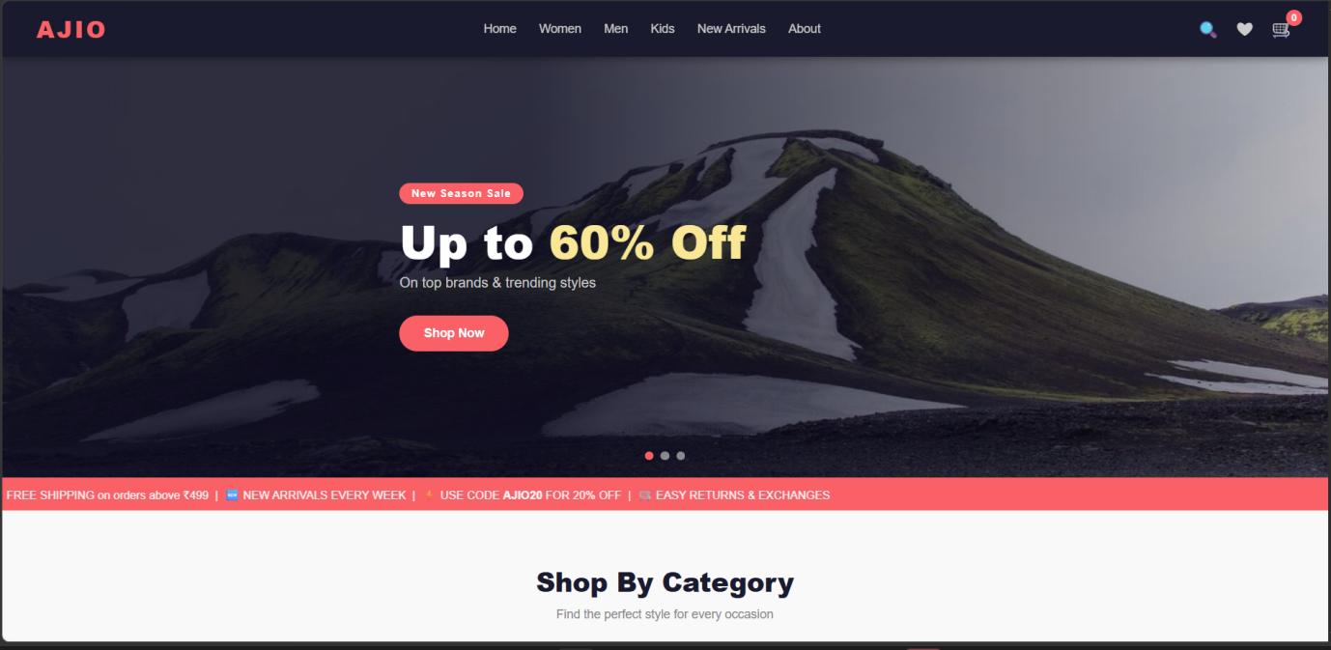

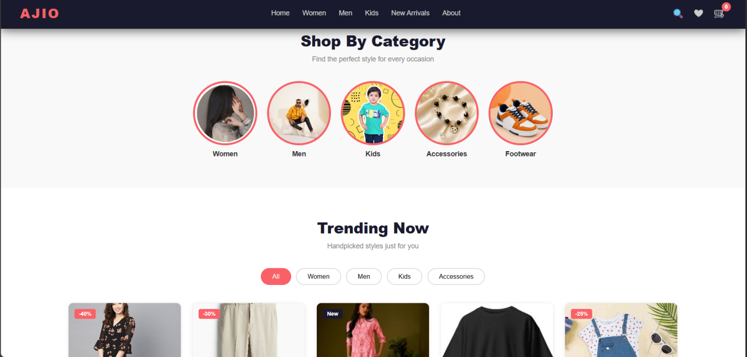

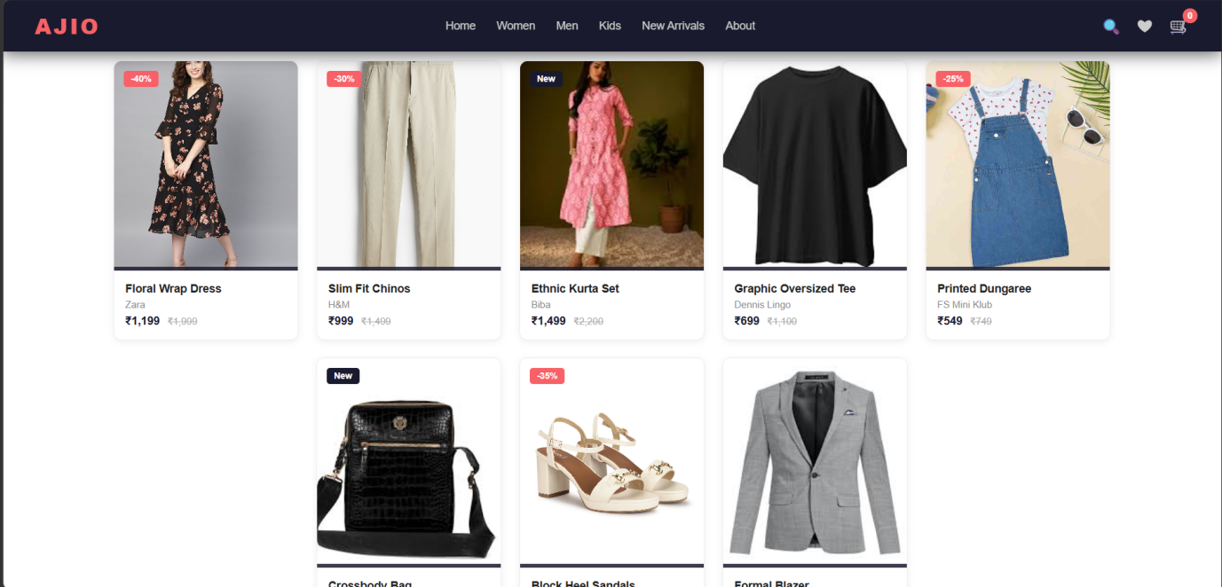

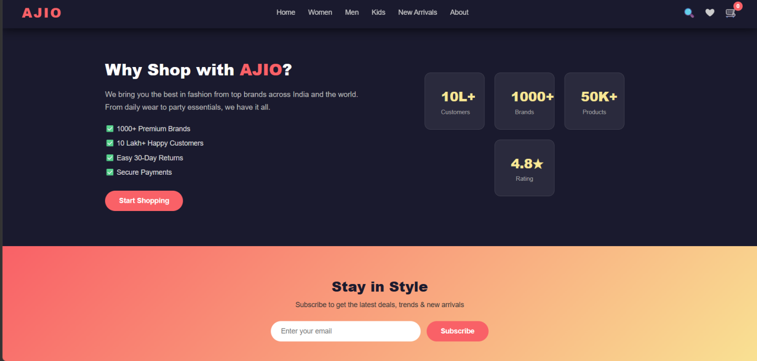

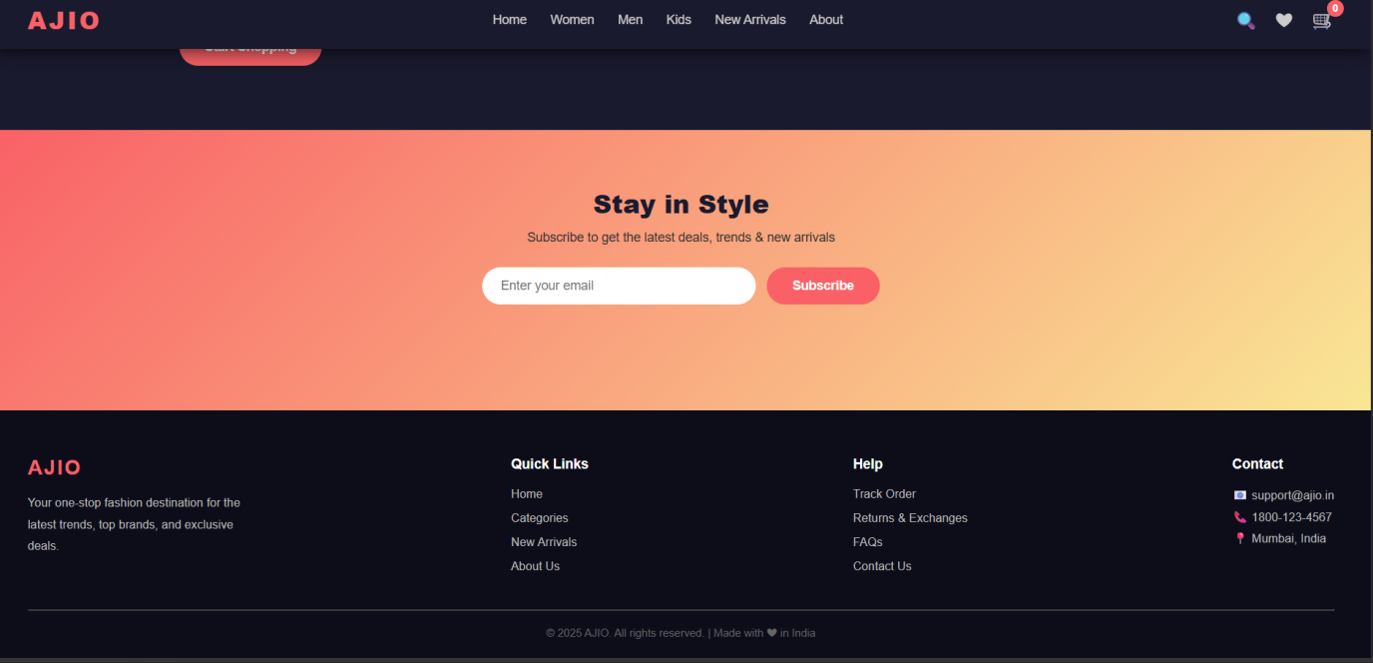

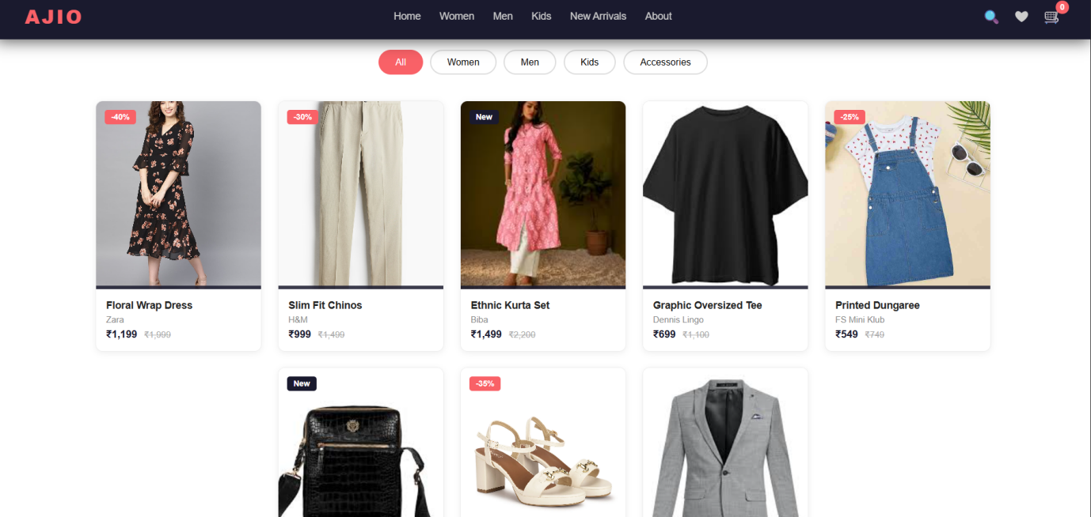

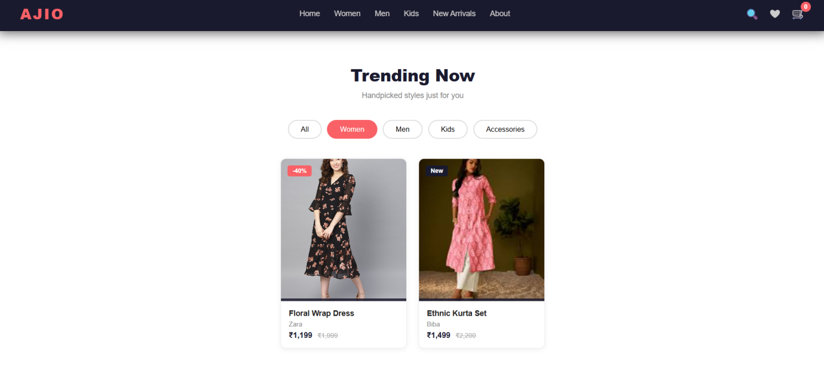

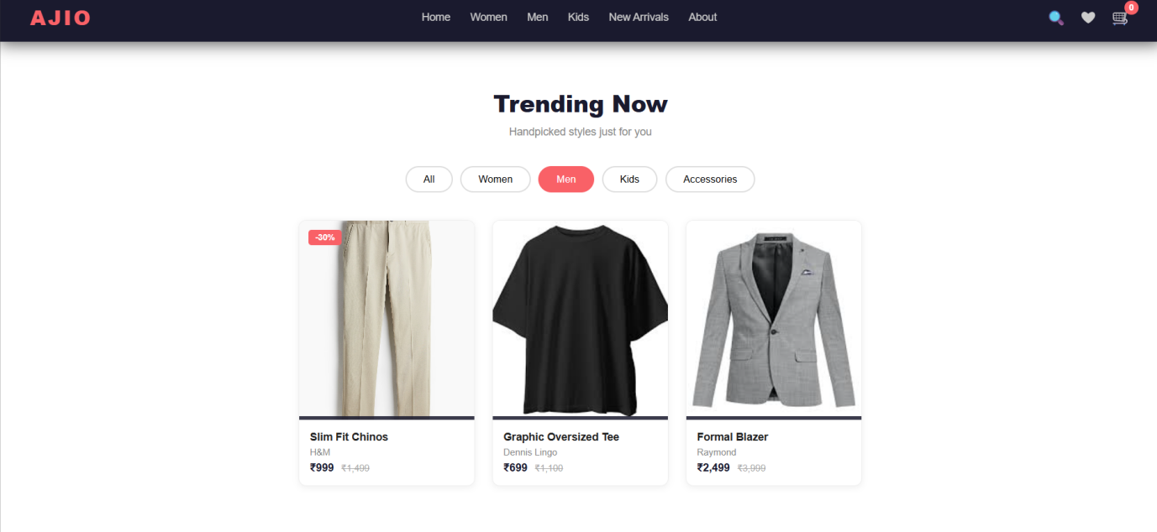

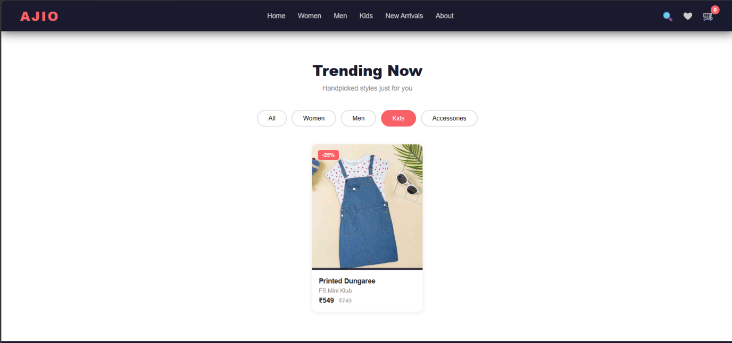

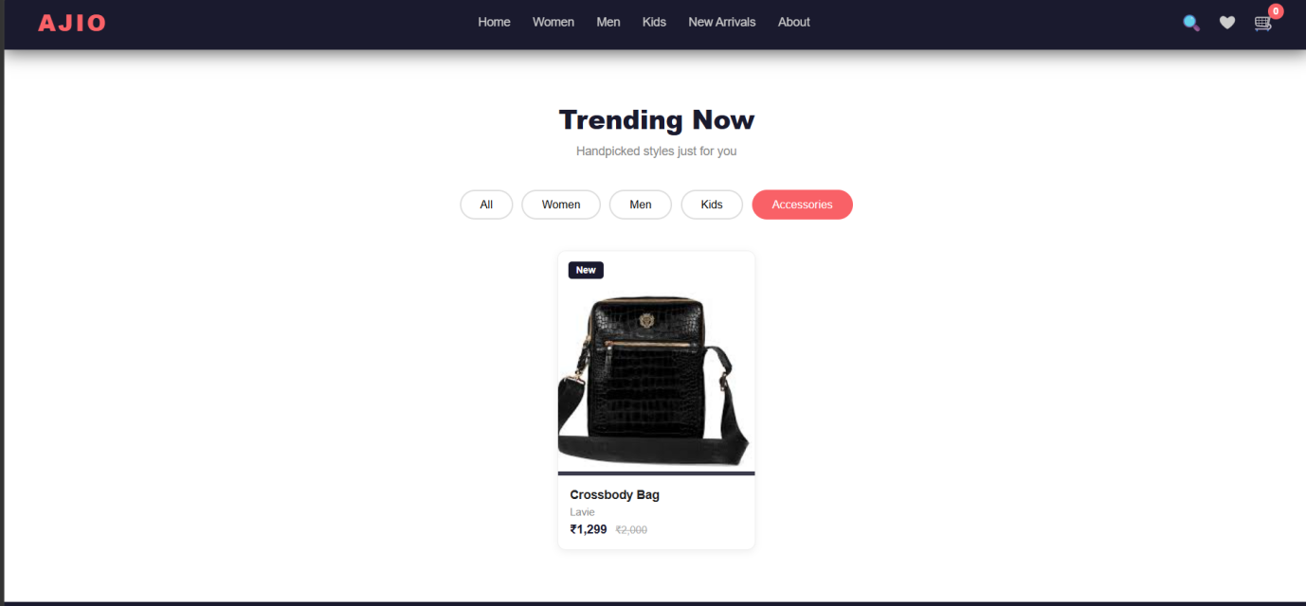

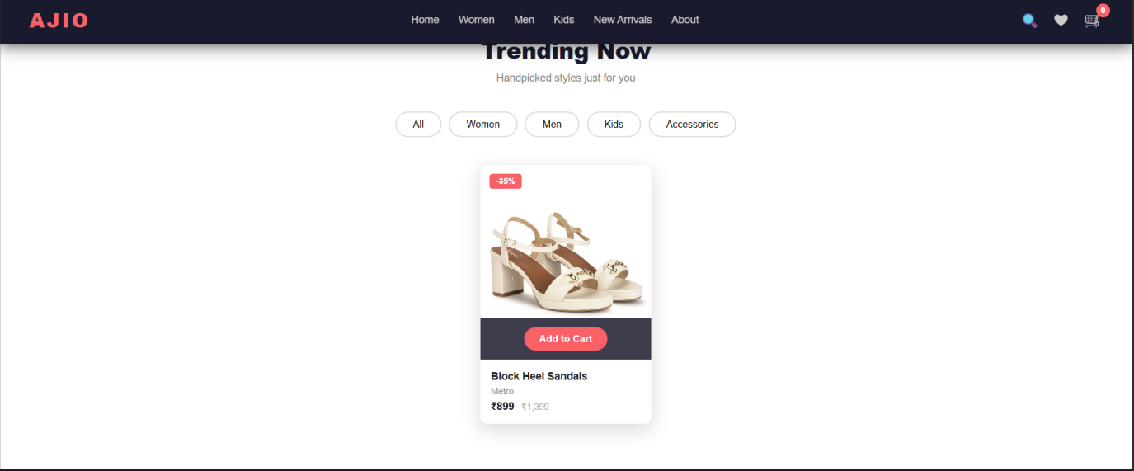

EXPLANATION:
This project is a responsive AJIO-inspired online shopping website
developed using HTML, CSS, and JavaScript. HTML is used to
create the structure of the website using tags such as <nav> for the
navigation bar, <section> for different webpage sections like hero,
categories, products, about, and newsletter, <div> for layout
containers, <ul> and <li> for navigation menus, <a> for links and
buttons, <img> for displaying images, <button> for interactive actions,
<form> and <input> for newsletter subscription, and <footer> for
contact and website information. CSS is used to style the entire
website by adding colors, layouts, Flexbox positioning, animations,
hover effects, gradients, shadows, responsive design, product card
styling, image effects, and mobile-friendly media queries. JavaScript
is used to add interactivity and dynamic functionality such as the
sticky navbar effect during scrolling, hamburger menu toggle on
mobile devices, automatic and manual hero image slider, category-
based product filtering, cart count update, toast notification popup,
newsletter email validation, smooth scrolling between sections, and
scroll reveal animations for product cards. Overall, the project
demonstrates frontend web development skills including semantic
HTML structure, modern CSS styling, responsive web design, DOM
manipulation, event handling, animations, filtering systems, and
interactive user interface design to create a visually appealing and
user-friendly e-commerce shopping website.

